ΑΠΑΝΤΗΣΕΙΣ ΦΥΣΙΚΗ ΓΕΝΙΚΗΣ Γ΄ΛΥΚΕΙΟΥ
2007

ΘΕΜΑ 1^{Ο}

- β
- γ
- γ
- β
- α. Λ β. Σ γ. Λ δ. Λ ε. Λ

ΘΕΜΑ 2^{Ο}

- γ. Αιτιολόγηση

$$\begin{aligned}\left.λ_{\text{min}1}=\frac{h⋅c}{\text{eV}} | \right\}\end{aligned}⇒\begin{aligned}\left.\frac{λ_{\text{min}1}}{λ_{\text{min}2}}=2 | \right\}\end{aligned}⇒\frac{\frac{c}{f_{1}}}{\frac{c}{f_{2}}}=2⇒\frac{f_{2}}{f_{1}}=2⇒f_{1}=\frac{f_{2}}{2}$$

- α. Αιτιολόγηση

$\begin{aligned}\left.T_{A}=4T_{B} | \right\}\end{aligned}⇒\frac{\text{ln}2}{λ_{Α}}=4\frac{\text{ln}2}{λ_{Β}}⇒λ_{Β}=4λ_{Α}$ (1)

$\begin{aligned}\left.{\left|\frac{\text{ΔΝ}}{Δt}\right|}_{A}=λ_{Α}⋅Ν_{0} | \right\}\end{aligned}⇒\frac{{\left|\frac{\text{ΔΝ}}{Δt}\right|}_{A}}{{\left|\frac{\text{ΔΝ}}{Δt}\right|}_{B}}=\frac{λ_{Α}}{λ_{Β}}\overset{(1)}{⇒}\frac{{\left|\frac{\text{ΔΝ}}{Δt}\right|}_{A}}{{\left|\frac{\text{ΔΝ}}{Δt}\right|}_{B}}=\frac{λ_{Α}}{4λ_{Α}}⇒{\left|\frac{\text{ΔΝ}}{Δt}\right|}_{A}=\frac{1}{4}{\left|\frac{\text{ΔΝ}}{Δt}\right|}_{B}$

- β. Αιτιολόγηση

$$\begin{aligned}\left.A:d=c_{A}⋅t_{A} | \right\}\end{aligned}⇒\begin{aligned}\left.\frac{1}{2}=\frac{c_{A}⋅t_{A}}{c_{B}⋅t_{B}} | \right\}\left.n_{A}=\frac{λ_{0}}{λ_{Α}}=\frac{c_{0}}{c_{A}}⇒c_{A}=\frac{λ_{Α}⋅c_{0}}{λ_{0}} | \right\}\end{aligned}⇒\frac{1}{2}=\frac{\frac{λ_{Α}⋅c_{0}}{λ_{0}}⋅t_{A}}{\frac{λ_{Β}⋅c_{0}}{λ_{0}}⋅t_{B}}⇒\frac{1}{2}=\left.\begin{matrix}\frac{λ_{Α}⋅t_{A}}{λ_{Β}⋅t_{B}} \\ λ_{Α}=\frac{λ_{Β}}{2}\end{matrix}\right\}⇒$$

$$⇒\frac{1}{2}=\frac{\frac{λ_{Β}}{2}⋅t_{A}}{λ_{Β}⋅t_{B}}⇒t_{A}=t_{B}$$

ΘΕΜΑ 3^{Ο}

α. $E_{\text{ιον}}=Ε_{∞}−Ε_{n}=0,\text{85}⇒0−E_{n}=0,\text{85}⇒E_{n}=−0,\text{85}\text{eV}$

αλλά: $E_{n}=\frac{E_{1}}{n^{2}}⇒n^{2}=\frac{E_{1}}{E_{n}}=\frac{−\text{13},6}{−0,\text{85}}⇒n=4$
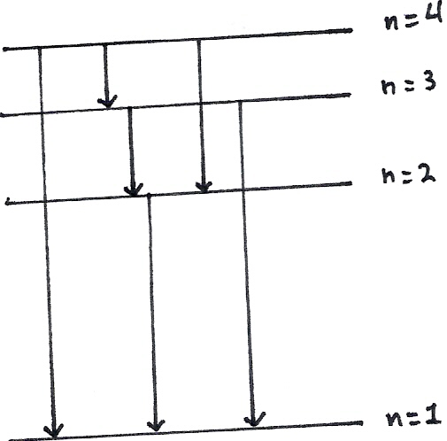

β.

γ. $\frac{\text{75}}{\text{100}}K=E_{4}−E_{1}⇒K=\frac{\text{100}}{\text{75}}\left(−0,\text{85}+\text{13},6\right)⇒K=\text{17}\text{eV}$

δ. $E_{1→4}=E_{4}−E_{1}=\text{12},\text{75}\text{eV}$
$$E_{1→4}=h⋅f⇒f=\frac{E_{1→4}}{h}=\frac{\text{12},\text{75}}{4,\text{25}⋅{\text{10}}^{−\text{15}}}=3⋅{\text{10}}^{\text{15}}\text{Hz}$$

ΘΕΜΑ 4^{Ο}

α) ${}_{5}^{\text{11}}{}B+{}_{1}^{1}{}H→3{}_{2}^{4}{}\text{He}$

β) Q=Δm·c²= (Μ_{B}+Μ_{H}-3Μ_{a})c²$⇒$
$$⇒Q=M_{B}⋅c^{2}+M_{H}⋅c^{2}−3M_{a}c^{2}=\text{10260}+\text{940}−3⋅\text{3730}$$
$$⇒Q=\text{11200}−\text{11190}⇒Q=\text{10}\text{MeV}$$

γ) αφού Q>0 άρα ΕΞΩΘΕΡΜΗ
δ) Κ_{τέλος}=2ΜeV+10MeV=12MeV

